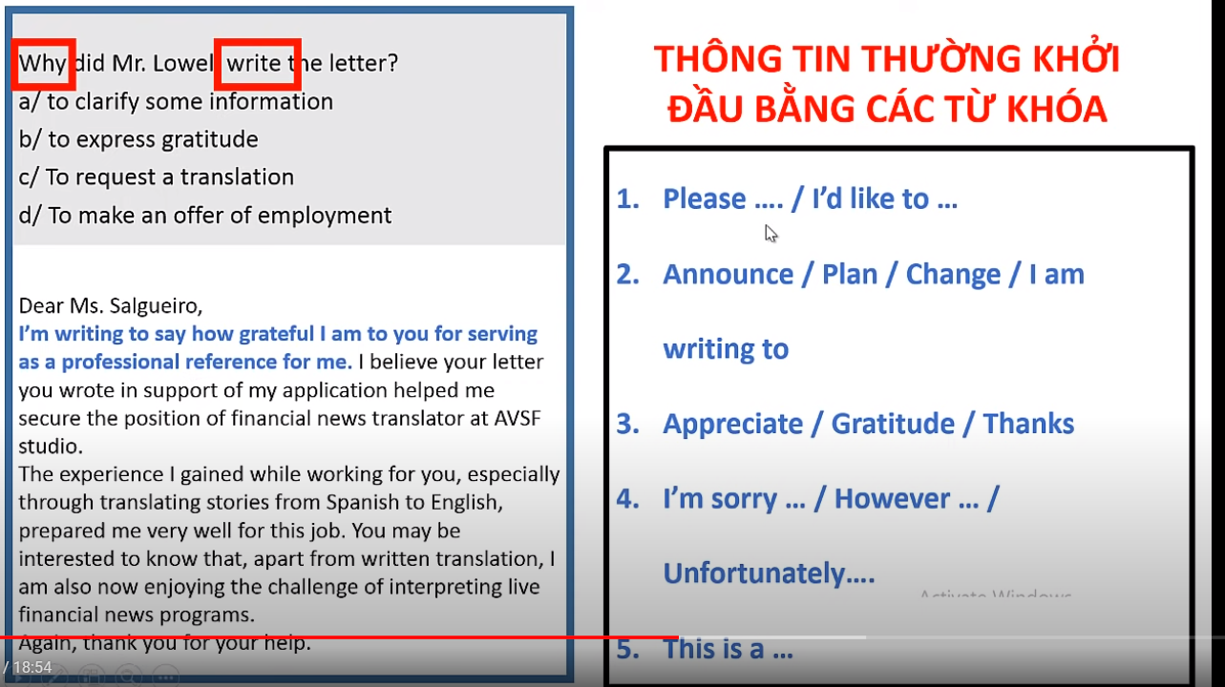

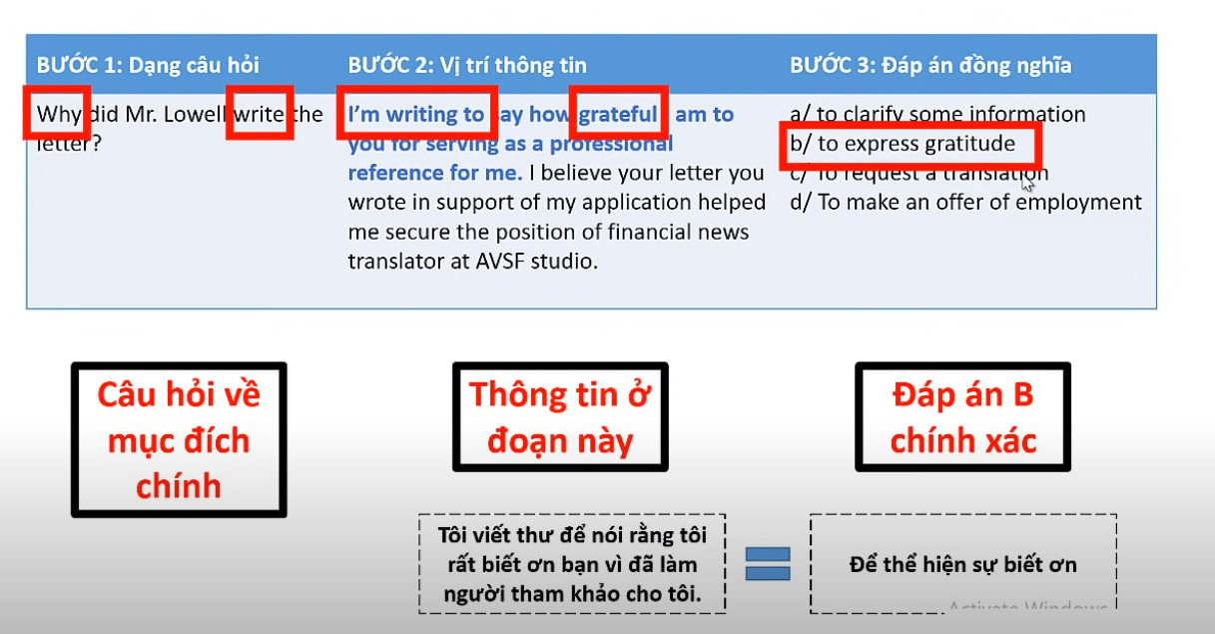

**After S + VQKHT, S + VQKĐ**

**After S + VQKĐ, S + VHTĐ**

**After S + VQKĐ, S + VQKĐ**

**After S + VHTĐ/HTHT, S + VTLĐ**

**Before S + VQKĐ, S + VQKHT**

**Before S + VHTĐ, S + VHTĐ/TLĐ**

**When S +** **VHTĐ, S + VHTĐ/TLĐ**

**When S + VQKĐ, S + VQKHT**

**When + S + VQKĐ, S + VQKĐ**

**When + S + VQKTD, S + VQKĐ**

**When S + VQKHT, S + VQKĐ**

**When S + VQKĐ, S + VQKTD**

**When S +** **VHTĐ, S + will be Ving**